SIMATS ENGINEERING (SAVEETHA SCHOOL OF ENGINEERING)
Department of Computer Science and Engineering
CO2 ASSESSMENT TOOL 1 – Scenario-Based Requirement Analysis

Course Code: | CSA10 | Course Title: | Software Engineering
CO Assessed: | CO2 | Assessment: | Assessment Tool 2 – Scenario-Based Requirement Analysis
Weightage: | 20% | Total Marks: | 25
CO2 Statement: | Perform detailed requirements analysis, design scalable architectures, and prioritize features with a focus on cross-disciplinary skills
Student Name: | S RUPESH | Reg. No.: | 192571055
Date: | 04.08.2026 | Duration: | 60 minutes
Rubrics for Calculation
Criteria | Excellent (4 Marks) | Good (3 Marks) | Satisfactory (2 Marks) | Needs Improvement (1 Mark)
Scenario Understanding and Problem Analysis | Demonstrates thorough understanding of the scenario, stakeholders, objectives, and business context with clear analysis. | Demonstrates good understanding with minor omissions. | Basic understanding with limited analysis. | Poor understanding; major aspects missing or incorrect.
Functional and Non-Functional Requirement Identification | Clearly identifies comprehensive, accurate, and well-classified functional and non-functional requirements. | Identifies most requirements with minor classification errors. | Identifies only basic requirements; several omissions. | Requirements are incomplete, inaccurate, or poorly classified.
Actor Identification and Use Case Modeling | Correctly identifies all relevant actors and use cases; use case diagram is complete, accurate, and follows UML standards. | Most actors and use cases identified; diagram has minor errors. | Limited actors/use cases identified; diagram partially correct. | Actors/use cases missing or incorrect; diagram absent or inaccurate.
Software Requirement Specification (SRS) Documentation | SRS is well-structured, complete, professionally organized, and includes all required sections. | SRS is organized with minor missing sections or formatting issues. | SRS includes only essential sections with limited detail. | SRS is incomplete, poorly organized, or lacks essential components.
Assumptions, Constraints, and Requirement Validation | Clearly identifies realistic assumptions and constraints; validates requirements for completeness, consistency, and ambiguity with appropriate justification. | Identifies most assumptions and constraints; validation is adequate. | Limited assumptions/constraints; validation is superficial. | Assumptions, constraints, and validation are missing or incorrect.

Criteria | Mark
Scenario Understanding and Problem Analysis | /5
Functional and Non-Functional Requirement Identification | /5
Actor Identification and Use Case Modeling | /5
Software Requirement Specification (SRS) Documentation | /5
Assumptions, Constraints, and Requirement Validation | /5
TOTAL | /5

INTRODUCTION
Mining is one of the most hazardous industries, where workers are exposed to risks such as equipment failures, toxic gas leaks, extreme environmental conditions, and underground accidents. Traditional safety systems mainly rely on manual inspections and periodic maintenance, making it difficult to detect hazards in real time and prevent accidents before they occur.

The AI-Based Smart Mining Safety and Equipment Monitoring Platform is designed to improve safety and operational efficiency by integrating Artificial Intelligence (AI), Internet of Things (IoT), wearable sensors, drones, and cloud computing. The system continuously monitors mining equipment, environmental conditions, and workers' health to identify potential risks. AI analyzes the collected data to predict equipment failures, detect hazardous situations, and generate instant emergency alerts.

This Software Requirements Specification (SRS) document defines the functional and non-functional requirements, system features, stakeholders, use cases, interfaces, assumptions, and constraints of the proposed platform. It serves as a blueprint for developing a reliable, secure, and scalable mining safety system that enhances worker protection, reduces operational risks, minimizes equipment downtime, and supports sustainable mining operations.

PROBLEM DESCRIPTION

Mining operations are carried out in hazardous environments where equipment failures, toxic gas leaks, extreme temperatures, and unsafe working conditions can lead to serious accidents and operational delays. Traditional monitoring systems rely on manual inspections and periodic maintenance, making it difficult to identify risks in real time and prevent unexpected failures.

The proposed AI-Based Smart Mining Safety and Equipment Monitoring Platform addresses these challenges by using Artificial Intelligence (AI), IoT sensors, wearable devices, drones, and cloud analytics to continuously monitor mining equipment, environmental conditions, and worker health. The system predicts equipment failures, detects hazardous situations, generates instant emergency alerts, and provides real-time monitoring through an intelligent dashboard. This helps improve worker safety, reduce equipment downtime, enhance emergency response, and increase overall mining efficiency.

SCOPE OF THE SYSTEM

The AI-Based Smart Mining Safety and Equipment Monitoring Platform is designed to improve safety, reliability, and operational efficiency in mining environments through continuous monitoring and intelligent decision-making. The system continuously collects data from IoT sensors, wearable devices, and drones to monitor equipment health, environmental conditions, and worker safety in real time. Using Artificial Intelligence (AI), it predicts equipment failures, detects hazardous situations such as gas leaks or abnormal conditions, and generates instant emergency alerts.

The platform also provides real-time dashboards for supervisors, supports predictive maintenance, stores operational data in the cloud, and generates analytical reports for better decision-making. By integrating advanced technologies, the system helps reduce accidents, minimize equipment downtime, improve emergency response, and promote safe and sustainable mining operations.

FUNCTIONAL REQUIREMENT
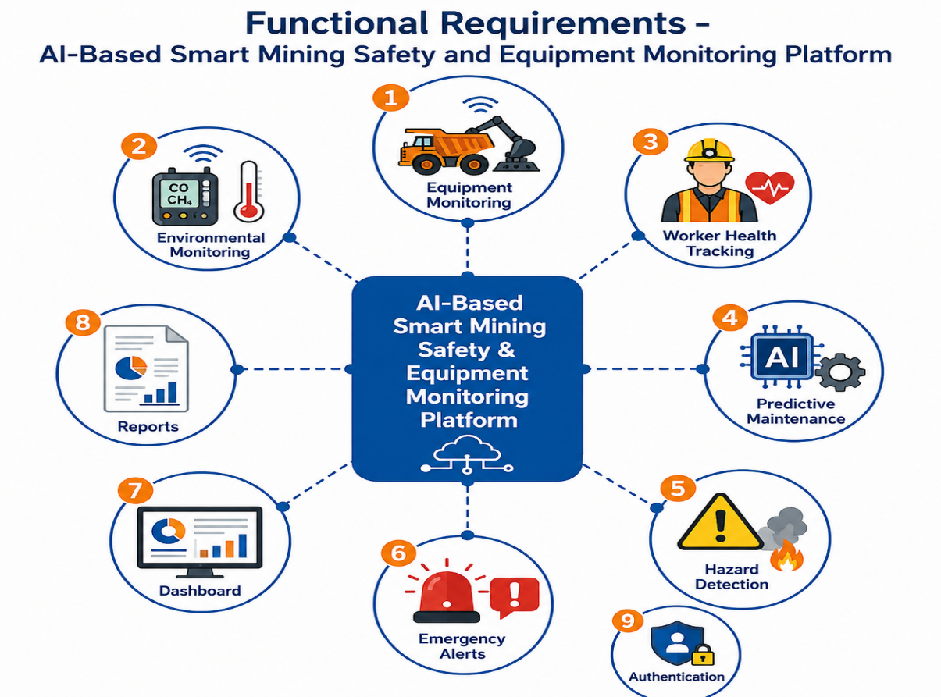

NON-FUNCTIONAL REQUIREMENT

The following non-functional requirements define the quality attributes of the AI-Based Smart Mining Safety and Equipment Monitoring Platform:

1. Performance
- The system should process sensor data and update the dashboard in real time.
- Emergency alerts should be generated within 5 seconds of detecting a hazard.
- The system should support monitoring of multiple mining sites and hundreds of IoT devices simultaneously.
2. Security
- Only authorized users should be allowed to access the system.
- All user and sensor data should be encrypted during storage and transmission.
- Role-based access control should be implemented for different users such as Admin, Supervisor, and Safety Officer.
3. Reliability
- The system should provide accurate monitoring and continuous operation with minimal failures.
- It should automatically recover from temporary hardware or network failures.
- Regular data backup should prevent data loss.
4. Availability
- The platform should be available 24×7 to ensure uninterrupted monitoring.
- System maintenance should have minimal downtime.
5. Scalability
- The system should support the addition of new sensors, equipment, workers, and mining locations without affecting performance.
- It should be capable of handling increasing volumes of data as mining operations expand.
6. Maintainability
- The software should have a modular design for easy updates and maintenance.
- Faults should be easy to identify and fix with proper logging and diagnostics.
7. Usability
- The dashboard should provide a simple, user-friendly interface with clear visualizations.
- Users should be able to access reports and alerts without extensive training.
8. Portability
- The system should be accessible through web browsers and mobile devices.
- It should support deployment on different operating systems such as Windows and Linux, as well as cloud platforms.

ACTORS

The following actors interact with the AI-Based Smart Mining Safety and Equipment Monitoring Platform to ensure safe and efficient mining operations.

Actor | Description / Role
Mine Worker | Wears IoT-enabled safety devices, receives emergency alerts, and reports incidents or emergencies.
Supervisor | Monitors mining operations through the dashboard, tracks workers, and oversees equipment status.
Safety Officer | Monitors environmental conditions, reviews hazard alerts, and ensures compliance with safety regulations.
Maintenance Engineer | Receives predictive maintenance notifications, inspects equipment, performs repairs, and updates maintenance records.
Administrator (Admin) | Manages user accounts, system settings, IoT devices, permissions, and overall platform administration.
IoT Sensors (Secondary Actor) | Collect real-time data such as equipment condition, gas levels, temperature, humidity, vibration, and pressure, and send it to the system.
AI Prediction Engine (Secondary Actor) | Analyzes sensor data, predicts equipment failures, detects hazardous situations, and generates intelligent recommendations.
Drone System (Secondary Actor) | Performs aerial surveillance, captures images and videos of mining sites, and identifies unsafe areas.
Emergency Rescue Team | Receives emergency alerts and responds quickly to accidents or hazardous situations to assist affected workers.

USE CASES

The following use cases describe the major functions performed by the AI-Based Smart Mining Safety and Equipment Monitoring Platform:
Use Case | Description | Primary Actor
Monitor Equipment | Continuously monitors the condition of mining equipment using IoT sensors to detect abnormal temperature, vibration, pressure, and other operational parameters. | Supervisor
Detect Hazards | Detects hazardous conditions such as toxic gas leaks, fire, high temperature, or unsafe environmental conditions and generates immediate alerts. | Safety Officer
Track Workers | Tracks the real-time location and health status of mine workers using wearable devices to ensure their safety. | Mine Worker
Predict Equipment Failures | Uses AI to analyze sensor data and predict equipment failures before they occur, enabling predictive maintenance. | Maintenance Engineer
Generate Reports | Generates daily, weekly, and monthly reports on equipment performance, worker safety, incidents, and maintenance activities. | Supervisor / Safety Officer
Manage Users | Allows the administrator to add, update, delete, and manage user accounts, roles, permissions, and system settings. | Administrator

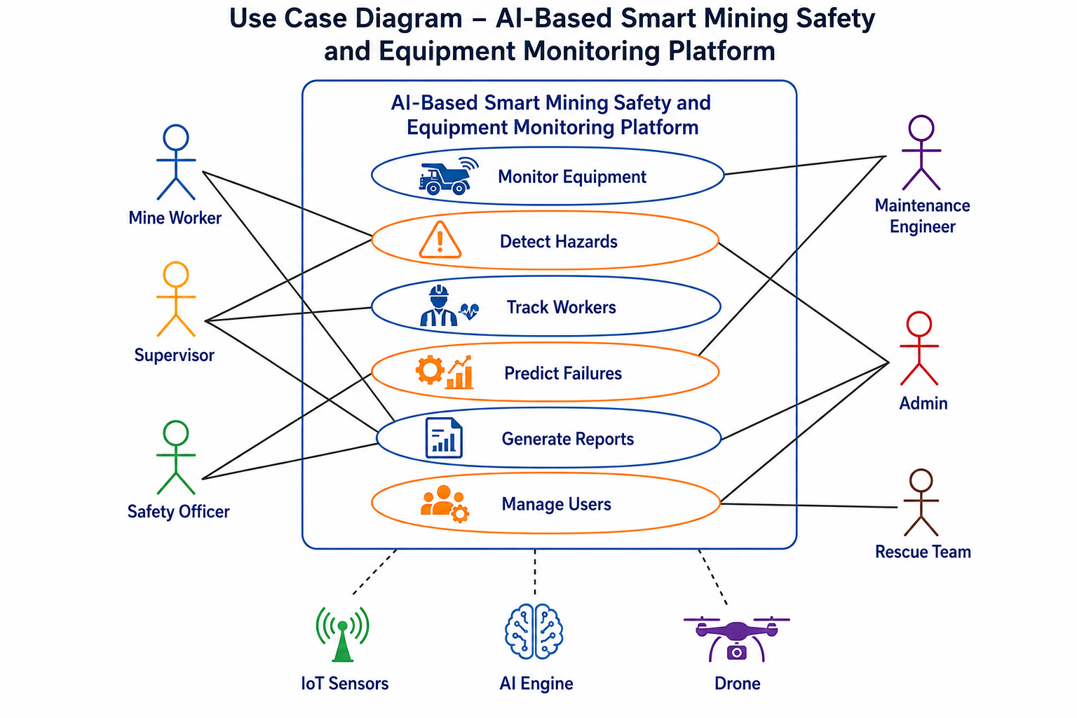

DATA REQUIREMENTS

The AI-Based Smart Mining Safety and Equipment Monitoring Platform requires the collection, storage, processing, and management of various types of data to ensure efficient monitoring, predictive maintenance, and worker safety.

1. Sensor Data
The system collects real-time data from IoT sensors installed on mining equipment and in the mining environment. This includes temperature, vibration, pressure, humidity, gas concentration (methane, carbon monoxide), dust levels, and equipment operating status.
2. Worker Data
The system stores information about mine workers, including employee ID, name, department, location, health parameters (heart rate, body temperature, oxygen level), and emergency contact details collected through wearable devices.
3. Equipment Data
The platform maintains records of mining equipment such as equipment ID, machine type, operational status, installation date, maintenance history, sensor readings, and current health condition.
4. Alert Data
The system records all alerts generated during hazardous situations, including alert ID, alert type, severity level, time of occurrence, affected location, and response status.
5. Maintenance Records
The system stores predictive and preventive maintenance information, including maintenance schedules, fault descriptions, repair history, technician details, spare parts used, and maintenance completion status.
6. Reports
The platform generates and stores operational reports such as daily monitoring reports, equipment performance reports, worker safety reports, incident reports, maintenance reports, and environmental analysis reports for future reference and decision-making.

EXTERNAL INTERFACE REQUIREMENTS

The AI-Based Smart Mining Safety and Equipment Monitoring Platform interacts with various hardware, software, and communication interfaces to ensure seamless data collection, processing, and monitoring.

1. Hardware Interface
The system connects with IoT sensors, wearable devices, drones, and mining equipment to collect real-time operational and environmental data. These devices monitor equipment condition, worker health, gas levels, temperature, humidity, vibration, and other safety-related parameters.
2. Software Interface
The platform provides a web-based dashboard for supervisors and administrators and a mobile application for workers and safety officers to monitor activities and receive alerts. It also integrates with cloud servers for secure data storage, AI-based analytics, and report generation.
3. Communication Interface
The system uses communication technologies such as Wi-Fi, MQTT (Message Queuing Telemetry Transport), and LoRaWAN (Long Range Wide Area Network) to enable reliable transmission of sensor data, equipment status, and emergency alerts between devices, the cloud, and end users.

ASSUMPTIONS

The development of the AI-Based Smart Mining Safety and Equipment Monitoring Platform is based on the following assumptions:
- A stable internet or network connection is available for communication between IoT devices, cloud servers, and monitoring dashboards.
- All IoT sensors, wearable devices, and drones are properly installed, calibrated, and functioning correctly.
- Mine workers consistently wear the provided smart wearable devices during working hours.
- The AI model has been trained using accurate and sufficient historical mining data to provide reliable predictions.
- Mining equipment is compatible with IoT sensors for real-time data collection.
- Authorized users such as administrators, supervisors, and safety officers have secure access to the system.
- Adequate power supply is available to support sensors, wearable devices, drones, and communication equipment.
- Emergency response teams are available to respond promptly when alerts are generated by the system.

CONSTRAINTS

The development and implementation of the AI-Based Smart Mining Safety and Equipment Monitoring Platform are subject to the following constraints:
1. Technical Constraints
- Limited network connectivity in underground mining areas may affect real-time data transmission.
- IoT sensors and wearable devices require regular maintenance and calibration.
- AI prediction accuracy depends on the quality and availability of historical data.
- Battery life of wearable devices and sensors may limit continuous operation.
2. Operational Constraints
- Workers must wear smart safety devices at all times for accurate monitoring.
- Regular maintenance of sensors, drones, and communication equipment is required.
- Staff should be trained to operate and monitor the system effectively.
3. Economic Constraints
- High initial cost for purchasing IoT sensors, wearable devices, drones, and cloud infrastructure.
- Ongoing expenses for system maintenance, software updates, and equipment replacement.
- Budget limitations may affect the deployment of advanced technologies.
4. Legal Constraints
- The system must comply with mining safety regulations and occupational health standards.
- Personal and operational data must be protected according to data privacy and cybersecurity laws.
- Environmental monitoring should follow government and industry compliance requirements.
5. Time Constraints
- The project must be completed within the allocated development schedule.
- System testing, AI model training, and deployment should be finished before the planned implementation date.
- Regular updates and maintenance should be performed without significantly interrupting mining operations.

REQUIREMENT VALIDATION

Requirement validation ensures that the AI-Based Smart Mining Safety and Equipment Monitoring Platform meets stakeholder needs and that all requirements are clear, complete, and consistent before system development begins.
1. Completeness
- All stakeholder requirements have been identified and documented.
- Functional and non-functional requirements are included.
- Use cases, data requirements, interfaces, assumptions, and constraints are clearly specified.
- The system requirements cover all major mining safety and equipment monitoring functions.
2. Consistency
- All requirements are consistent with the project objectives and problem statement.
- There are no conflicting or contradictory requirements.
- The terminology and definitions used throughout the SRS are uniform and standardized.
3. Ambiguity Check
- Requirements are written in simple, clear, and measurable language.
- Technical terms are properly defined to avoid misunderstanding.
- Performance-related requirements specify measurable values, such as response time and system availability.
4. Redundancy Check
- Duplicate or repeated requirements have been removed.
- Each requirement is unique and contributes to the overall functionality of the system.
- Similar requirements are grouped together for better organization.
5. Suggested Improvements
- Integrate AI-based image analysis to detect structural cracks and unsafe mining conditions.
- Add multilingual support to improve communication with workers.
- Include predictive analytics dashboards for advanced operational insights.
- Implement automatic backup and disaster recovery mechanisms.
- Enhance cybersecurity with multi-factor authentication and regular security audits.

CONCLUSION
The AI-Based Smart Mining Safety and Equipment Monitoring Platform is a comprehensive solution designed to improve worker safety, equipment reliability, and overall mining operations. By integrating Artificial Intelligence (AI), IoT sensors, wearable devices, drones, and cloud analytics, the system enables real-time monitoring, predictive maintenance, hazard detection, and rapid emergency response.
The proposed platform helps reduce mining accidents, minimize equipment downtime, improve decision-making through intelligent data analysis, and ensure compliance with safety regulations. Overall, it enhances operational efficiency, supports sustainable mining practices, and creates a safer working environment for mine workers while increasing the productivity and reliability of mining operations.

